**Title: Stand dieback and collapse in a temperate forest and its impact on forest structure and biodiversity**

Authors: Philip Martin1, Adrian C. Newton1, Elena Cantarello1, Paul Evans1

Journal: Forest Ecology and Management

1 Centre for Conservation Ecology and Environmental Sciences, Faculty of Science and Technology, Bournemouth University, Poole, BH12 5BB, UK.

Keywords: forest dieback; regime shift; forest collapse; ecosystem resilience; climate change

Corresponding author email: martinp@bournemouth.ac.uk

**Abstract**

Concern is increasing about large-scale dieback that is occurring in many forest ecosystems. However, understanding of the processes of dieback and its potential impacts is limited, partly owing to the lack of long-term monitoring data for forest stands in which dieback has occurred. Here we present monitoring data collected for 50 years along two transects in a temperate forest ecosystem, in which the canopy dominant beech (*Fagus sylvatica* L.) has demonstrated significant dieback. Our results show that basal area in the forest has declined by 33%, and juvenile tree densities have also been reduced. Growing season temperatures have steadily increased and there have been a number of droughts causing water deficits in recent decades, particularly in 1995. We hypothesise that these droughts may have interacted with novel pathogenic fungi to cause mortality of large trees. Curvilinear responses to BA loss were observed in tree community change, species richness of the ground flora, and percentage cover of grass, providing evidence of thresholds associated with stand dieback. Evidence also suggested that the ability of BA to recover following decline demonstrated a threshold response; where BA declined by more than 25%, it tended not to recover. Critical values of BA for a change in ground flora species richness and grass cover were around 40% decline from initial values. While these changes are dramatic, they cannot be considered a regime shift as the pressures that caused the ecosystem transition, drought, pathogenic fungi and overgrazing, are ongoing.

While managers might consider accepting forest dieback as part of an adaptive response of the system to novel environmental conditions, this would likely be associated with significant change in biodiversity and ecosystem service provision.

**Introduction**

There is growing concern that on-going climate change may result in large-scale forest dieback as a result of increased drought and heat stress (Allen et al., 2010; Scholes et al., 2014). Examples of this include increases in tree mortality over the past 50 years in the western USA and boreal Canada, apparently as a result of regional warming and water deficit (Peng et al., 2011; van Mantgem et al., 2009). Changing climatic conditions have also allowed spread of bark and pine beetles, resulting in epidemics in the previously unaffected areas of the western USA and Canada (Kurz et al., 2008; Raffa et al., 2008). Though invertebrate herbivores play an important role in ecosystem functioning, when these species’ ranges expand beyond their native range this can result in widespread damage. Major diseases have also recently caused extensive tree mortality, including pine wilt in Asia, Dutch elm disease in Europe and North America, ash dieback in Europe (Pautasso et al., 2013) and *Phytophthora* spp. in Australia (Boyd et al., 2013). It is likely that the rate of spread of these diseases will increase with greater globalisation and climatic change (Boyd et al., 2013).

Despite such trends, the ecological implications of dieback or collapse of forest ecosystems are poorly understood. A recent IPCC assessment noted that increased tree mortality and associated forest dieback is projected to occur in many regions over the 21st century, and that this is likely to pose risks for biodiversity, carbon storage and other ecosystem services (Scholes et al., 2014). However, the magnitude of such risks has not been evaluated in detail (Bellassen and Luyssaert, 2014; Boyd et al., 2013). The long-term impacts of dieback will depend critically on the ability of forest ecosystems to recover from disturbance. Of particular concern are rapid transitions or “regime shifts”, which have been documented in a number of different ecosystem types following major disturbance events (Scheffer and Carpenter, 2003; Scheffer et al., 2001, 2012).

Regime shifts are thought to occur when the controlling variables in a system (including feedbacks) result in the alteration of the system structure and dynamics (Walker et al., 2004). Once a regime shift has occurred, because an ecological threshold has been crossed, recovery to the original ecosystem state may be difficult (Petraitis, 2013). While the underlying theory of regime shifts or abrupt transitions is well established (Bestelmeyer et al., 2011; Scheffer and Carpenter, 2003; Scheffer et al., 2001, 2012), their existence in forest ecosystems remains the subject of debate (Petraitis, 2013). Theories relating to regime shifts and thresholds in ecosystems suggest that declines are likely to be non-linear, and may be characterised by feedbacks between different pressures (Scheffer et al., 2001, 2012). Understanding the pattern of such responses is of critical importance to ecosystem resilience which is increasingly being incorporated into environmental policy, and are consequently becoming the explicit focus of forest management (Newton and Cantarello, 2015). From a management and policy perspective, there is also a need to understand the potential consequences both for biodiversity and the associated provision of ecosystem services (Groffman et al., 2006).

Here we use a long-term data set, collected in a temperate forest ecosystem that has undergone partial stand dieback in recent decades. In this location in southern England, monitoring data have been collected repeatedly over a period of 50 years. Here we build on data collected from 1964-2001 (Mountford and Peterken, 2003; Mountford et al., 1999) through an additional survey undertaken in 2014, and for the first time explore the entire data set from the perspective of analysing ecosystem thresholds and regime shifts. Specifically, in this paper we aim to: (1) describe the pattern of stand dieback in the woodland over the past five decades, (2) identify the ecological processes that might be driving the changes, (3) identify the consequences of these changes for forest structure and plant biodiversity.

**Methods**

**Site history and characteristics**

The site used in this study, Denny Wood, is located in the New Forest National Park in Southern England (Lat: 50o 51.5’ N and 1o 32.5’ W). It has a temperate oceanic climate. Mean annual precipitation between 1957 and 2014 ± SD at the Hurn weather monitoring station approximately 23km from Denny Wood was 832 ± 150mm and mean annual temperature was 10.17 ± 0.64°C (www.metoffice.gov.uk/public/weather/climate-historic/ - accessed 16/04/2015).

Detailed site descriptions are provided Mountford et al. (1999) and Mountford and Peterken (2003) and are briefly summarized here. The site is situated on gentle slopes (1–3°), primarily on clay-rich brown earth soils (pH 4.5–5.0 at 10 cm depth) that are prone to winter waterlogging and summer drying, with localised areas of strongly acid (pH 3.5–4.5) podsols developed on sandier substrates. Woodland vegetation is dominated by beech (*Fagus sylvatica*)withfrequent pedunculate oak (*Quercus robur*) and occasional birch (*Betula pendula, B. pubescens*), and an understorey primarily composed of holly (*Ilex aquifolium*). In open areas, the ground vegetation is mostly comprised of *Agrostis*-dominated grassland or stands of bracken (*Pteridium aquilinum*); *Rubus fruticosus* agg., *Juncus effusus* and *Molinia caerulea* are also locally abundant.

The New Forest has high herbivore pressure owing to large populations of deer and free-roaming livestock (principally ponies and cattle), as a result of its long-term maintenance of a traditional commoning system (Newton, 2011; Newton et al., 2013). Although the area surveyed here has largely been untouched by silvicultural treatment, since 1870 it has been divided into two portions, one of which (Denny Inclosure) was enclosed by fencing to exclude livestock, but not deer. Although browsing pressure was higher in the unenclosed part of the site during the early 20th century, since the 1960s browsing pressure has increased in both areas (Mountford and Peterken 2003).

**Data collection**

Measurements were conducted in two 20 m-wide transects, which were originally established in the 1950’s. The first of these was established in Denny Inclosure and was 1 km in length, whereas a shorter transect of 320 m length was established in the unenclosed part of Denny Wood. The transects were subdivided into contiguous 20 x 20 m (0.04 ha) subplots, with the longer transect containing 46 subplots and the shorter transect 15. The enclosed transect was surveyed in 1964, 1984, 1988, 1996 and 2014, while the unenclosed transect was surveyed in 1964, 1999 and 2014. Details of earlier measurements are presented by Mountford et al. (1999) and Mountford and Peterken (2003); data for 2014 are presented here for the first time.

In each survey, the location and species of all tree stems >1.3 m in height were recorded, their diameter at breast height (DBH) measured using diameter tapes, and their status assessed as alive, alive but fallen, or dead. Trees with DBH <10 cm were classified as saplings and those with a DBH >10 cm classified as mature trees. Multi-stemmed trees were treated as separate individuals. To assess ground flora a 10 x 10 m plot was located in the central part of each 20 x 20 m subplot and the percentage cover of each plant species assessed visually. Ground flora data were recorded in 1964, 2001 and 2014 for Denny Inclosure and 2014 for the unenclosed transect. In 2014 tree seedling abundance was also recorded for Denny Inclosure within the same 10 x 10 m plots used to assess ground flora.

**Data preparation**

Basal area (BA) for all tree species ≥10 cm DBH was calculated for each subplot following Cantarello and Newton (2008). The percentage change in basal area for all species since 1964 for each subplot was calculated using the formula:

where represents the BA of a subplot in 1964 and represents the BA of a subplot in any of the subsequent survey years. Using these data, at each survey date we classified subplots into groups according to whether basal area had either remained stable or increased, or whether it had declined, defining a decline as a ≥25% reduction in BA since 1964.

To examine changes in plant biodiversity we calculated the species richness of subplots for both ground flora and for tree species as well as metrics of community composition change. To assess changes in tree community composition since 1964 we used the Tanner Index as defined by Chai et al. (2012) which is the mean of the Sørensen similarity indices calculated using BA and stem density. This metric avoids the problems of using the quantitative Sørensen similarity Index which when calculated using stem density as a measure of abundance the Index treats differently sized trees as equal, but when it is calculated using BA, differences in stem density are ignored. The quantitative Sørensen similarity index was used to assess changes in ground flora community composition since 1964.

Where response variables represented a proportion, such as percentage cover or the Tanner or Sørensen indices, we undertook the following transformation:

where is an individual variable value for plot for year and is the maximum value of the variable in the dataset. This transformation constrains model predictions between 1 and 0 as well as reducing the heteroschedasticity that is common when proportion data is incorrectly analysed (Warton and Hui, 2011). As recommended by Warton and Hui (2011), a small non-zero constant was added to all values so that logit transformed variables did not equal minus infinity.

**Analysis**

To assess changes in BA we calculated percentage change from 1964-2014 in each subplot. We then calculated the median change in subplot BA. For subsequent analyses of stand collapse we divided the dataset into subplots that had collapsed (defined as ≥25% BA loss) at some point between 1964 and 2014 and those that had not, to examine the differences in temporal changes in stem density of saplings and trees >10 cm DBH, changes in the stem density of different size classes, and grass cover for the two groups. For analysis of changes in stem density of different size classes we divided trees based on quartiles of tree DBH for the plots sampled – 10-15 cm, 15-25 cm, 25-45 cm and >45 cm DBH. For stem density and grass cover we fitted linear mixed models with an interaction between year and collapse status (i.e. collapsed or not).

Following this we examined what processes might be responsible for these changes. We hypothesised that changes in the forest may be partly driven by mortality as a result of climate change over the past 50 years. To test this we used data on temperature and precipitation from the closest weather station, Hurn approximately 25 km from Denny Wood. We used a subset of this data for the months April-September from 1964-2013. These months approximate the growing season for beech and oak and thus climate anomalies during this period may to affect growth and mortality. We calculated climatic water deficiency (CWD), a measure of water availability to plants following Lutz et al. (2010), to determine the potential severity of drought years. We calculated the overall mean April-September CWD and subtracted this from each year’s mean to produce a summary of CWD anomalies. We then classified those years that had a CWD more than 1 standard deviation greater than the mean as a drought, and those with a CWD more than 2 standard deviations above the mean as an extreme drought. In addition we performed regression analysis on the growing season temperature to examine change over time. However, we could not link climatic changes directly to mortality with our dataset since the temporal resolution of our dataset is not high enough and mortality caused by drought can occur many years after the event.

We examined the resilience of the forest by using linear mixed models to assess he recovery of subplots following declines in BA. To do this we calculated the time since any initial decline in BA for all subplots. Then we modelled the BA, and tree and ground flora community composition as a function of time since decline and initial severity of decline. This allowed us to determine whether (i) subplots showed signs of recovery from dieback and (ii) if there were thresholds beyond which recovery was not possible.

To test for threshold responses to dieback, we examined variation over a gradient of change in subplot basal area. The relationships between the collapse gradient and species richness, ground flora Sørensen similarity, tree community Tanner similarity and community weighted trait values were each assessed using linear mixed models. For each of these models, linear, squared and cubed terms describing the shape of the relationship with the collapse gradient were tested to identify any potential non-linearity. For assessments of grass cover, ground flora richness and community composition because one ground flora survey was undertaken in 2001 when no surveys of the tree community were undertaken values of BA from the 1996/9 surveys were used to estimate the gradient.

In analyses of ecological changes in the forest we used linear mixed models with subplot number as a random effect to account for repeated measures of the same subplots over time. Where the response variable constituted a count variable we used Poisson generalised linear mixed models. All analyses were performed in R 3.1.2 (R Development Core Team, 2011) with mixed models produced using the lme4 package (Bates et al., 2014) and figures produced using ggplot2 (Wickham, 2009). Model selection followed an information theoretic approach, with models ranked by AICc to determine parsimony (Burnham and Anderson, 2002). Where only one model had a ΔAICc≤7 this was selected as the best model since this indicates little support for alternative models (Burnham et al., 2011). Where there was more than one model with a ΔAICc≤7, model averaging was undertaken with AICc weights used to calculate coefficients and associated standard error and P values using the MuMIn package (Barton, 2014). R2 values for mixed models were calculated following Nakagawa and Schielzeth (2013) and Johnson (2014) using the R package MuMIn.

To examine the spatial pattern of change in BA we produced maps showing the percentage BA decline of each subplot relative to 1964. To determine whether there was evidence of spatial autocorrelation in the severity of stand collapse Moran’s I correlation was calculated for pairwise comparisons of BA change between unenclosed and enclosed subplots separately using the R package ncf (Bjornstad, 2013). We performed 1000 bootstrapped iterations to generate median values and 95% confidence intervals of Moran’s I values at lag distances of 20-1000 m, the minimum and maximum distance between subplots in the same transect. Where confidence intervals of the Moran’s I statistic overlapped zero, spatial autocorrelation was deemed to not be statistically significant.

**Results**

**Pattern of collapse**

Subplots showed a median decline in BA of 33% from 1964-2014 (Figure 1a). However, there were large variations in subplot changes in BA with some plots experiencing near 100% loss of BA and others increasing by >50% (Figure 1a). Declines in BA occurred in every survey period from 1964 to 2014. Between 1964 and 1984, 19 subplots declined in BA, between 1984 and 1988, 31 subplots declined in BA, and between 1996/9 and 2014, 13 subplots declined in BA. Of the subplots in the unenclosed transect 87% (14 out of 15) demonstrated BA loss over the entire survey period, while on the enclosed transect 48% (22 out of 46) showed declines.

Subplot stem density changes were best described by a regression model that included an interaction between survey year and whether subplots had collapsed at any point (Table S1). This model showed good fit (marginal R2=0.37); no other model had a ΔAICc ≤7 (Table S1). Subplots that collapsed and those that did not differ in their stem densities in 1964 (P=0.91), whereas both showed declines in stem density from 1964-2014. However, collapsed plots showed a more rapid decline in stem density than stable plots (slope=-0.029, SE=0.003, P<0.001, Figure 1b Table S2).

Similarly, the most parsimonious model for describing subplot density of trees >45 cm DBH included an interaction term between year and collapse status (Table S3). Density of trees >45 cm DBH subplots that subsequently collapsed and those that did not did not differ in 1964(P=0.057), but by 2014 collapsed plots had significantly lower stem densities (P<0.001). Mean (± SE) stem density of trees >45 cm DBH increased for stable plots from 68.75 (± 28.50) stems ha-1 in 1964 to 93.75 (± 29.50) in 2014 (P<0.001, Figure S1a, Table S4). Over the same time period the mean density of trees >45 cm DBH decreased in collapsed subplots from 84.5 (± 29.25) in 1964 to 37.75 (±31.25) trees ha-1 (P<0.001, Figure S1a,Table S4).

Trees with a DBH of 25-45 cm did not decrease in density for either stable (P=0.599) or collapsed plots (P=0.835). However, subplots that subsequently collapsed had a lower density of trees with a DBH of 25-45 cm in 1964 than did those that remained stable (P<0.001, Figure S1b, Table S6). Similarly, the density of trees with DBH of 15-25 cm was lower in subplots that subsequently collapsed in 1964 than those that remained stable (P<0.001, Figure S1c, Table S8), but there was no reduction in density by 2014 for collapsed or stable plots (P=0.426). Mean density of trees with a DBH of 10-15 cm declined between 1964 and 2014 for both collapsed and stable plots (P<0.001, Figure S1d, Table S10), but there were no significant differences between the two plot types in either 1964 (P=0.920) or 2014 (p=0.429).

Mean sapling density decreased for both collapsed and stable subplots between 1964 and 2014 (P<0.001, Figure S2, Tables S12 and S13), declining from 291 (± 28.75) to 70 (± 27.50) stems ha-1 in stable plots and from 321.25 (± 29.5) to 69.25 (± 26.75) stems ha-1 in collapsed plots. However there was no statistically significant difference between collapsed and stable plots in 1964 (P=0.289) or 2014 (P=0.620). Subplots that collapsed had a higher density of beech seedlings in 2014 (139.4 ± 1.2 seedlings ha-1) when compared to stable subplots (77.78 ± 1.1 seedlings ha-1, P<0.001). Similarly holly seedlings in 2014 were more abundant in collapsed subplots (3451.52 ± 18.39 seedlings ha-1) than in stable subplots (1903.70 ± 8.42 seedlings ha-1, P<0.001). However, oak seedling densities in 2014 were higher in stable than in collapsed subplots (122.22 ± 2.15 and 96.97 ± 2.44 seedlings ha-1 respectively, P<0.001).

Although visual inspection of maps suggested that subplots that were situated adjacent to collapsed plots appeared more likely to collapse (Figure S3), Moran’s I spatial correlograms indicated that spatial autocorrelation was not statistically significant at any pairwise distance between subplots that we examined (Figure S3).

**Causes of dieback**

The decline in BA for all subplots was 16.73 m2 ha-1, with 61% of this attributable to losses of beech BA and 34% to loss of oak BA. The combined mortality of beech and oak trees >45 cm in DBH was responsible for the majority of these declines, constituting 61% and 30% of total BA losses respectively. For other size classes, only oak 25-45 cm DBH contributed more than 5% of the declines in total BA loss.

We hypothesised that the loss of large trees in the woodland was partly due to changes in climate over the period 1964-2014. Growing season temperature increased from the 1960’s to 2014 at a rate of 0.02 ± 0.004°C year-1 (Figure 2a, R2=0.28). Though CWD showed no consistent trend over the period (Figure 2b) it was clear that severe droughts occurred in 1976 and 1995, and three drought years occurring since the year 2000.

**Consequences of dieback**

In plots where BA declined by ≥ 25% it tended not to recover. While many subplots increased in BA following an initial loss, only in those that had initial declines of <25% did BA recover to values exhibited in 1964, with 43% of these subplots (3 of 7) achieving this degree of recovery by 2014. However, even for subplots that declined by < 25% of initial BA, the majority (4 of 7 subplots) failed to recover to BA values evident in 1964; in 2014, mean BA of these subplots was 11.8% (± 6.06) lower in 1964. While some subplots that showed initial losses of BA >25% also increased in BA following initial loss, 66% of subplots actually lost further BA by 2014.

Tree species richness showed a negative relationship with loss of BA (slope=-0.284 ± 0.108 SE, P=0.009, Table S14) but the most parsimonious models had very poor explanatory power (marginal R2=0.03-0.04, Table S13). Turnover in tree communities, as indicated by the Tanner Index, was strongly related to loss of BA (Figure 4). This relationship was best predicted by a model including both a linear and squared term for percentage basal area loss (R2=0.39, AICc=330.93), which provided a better fit than models of linear relationships (AICc= 406.00) or a null model (AICc=510.44, Table S15). The best model suggested a curvilinear response in tree community change with loss of BA, with losses of BA associated with large changes in community structure (Figure 4). Changes in tree community weighted Ellenberg values for light, nitrogen and moisture requirements showed little discernible trend with the decline in basal area, and in each case a null model was considered most parsimonious.

Changes in subplot grass cover were best described by a model with an interaction term between year and whether subplots collapsed during 1964-2014 (marginal R2=0.44, Table S17). In 1964, grass cover did not differ between subplots that subsequently collapsed and those that did not (P=0.64, Figure 5, Table S18), but by 1996 collapsed subplots showed four-fold higher grass cover (Stable: 5.2% (± 3.5), Collapsed: 22.8% (± 8.8), P=0.009). This difference had increased by 2014 (Stable: 3.8% (± 2.7), Collapsed: 26.7% (± 9.4), P<0.001, Figure 5). Changes in grass cover in subplots were strongly related to loss of BA, showing a non-linear relationship (Figure 6a). Model predictions suggested relatively little change in grass cover in subplots that increased in BA or showed losses <25%, while subplots that lost ≥25% of BA showed a rapid increase in grass cover with increasing loss of BA (Figure 6a). In contrast to grass, bracken (*Pteridium aquilinum)* cover showed no significant relationship with loss of subplot BA with a null model the most well supported (Tables S19 and S20, Figure S4).

Ground flora richness showed a positive non-linear relationship with BA loss (Tables S21 and S22). Model averaged predictions suggested little difference in ground flora richness for subplots that showed <40% loss of BA, with an increase in species richness for subplots with greater declines in BA (Figure 6b). Loss of basal area did not describe changes ground flora community composition well, with a null model best supported.

Community weighted Ellenberg values for ground flora light requirements increased with increasing loss of BA (P=0.030, Table S24), though the top ranked models showed relatively poor fit (marginal R2 = 0.10, Table S23). Neither community weighted Ellenburg values for nitrogen nor moisture requirements showed any significant trend with the gradient of BA loss and all models showed poor descriptive power with marginal R2<0.04 (Tables S25 and S26).

**Discussion**

Our study provides a number of insights into the changes that occurred in a temperate forest ecosystem undergoing stand dieback over several decades. This process of dieback largely resulted from death of large (>45 cm DBH) beech and oak trees. This was accompanied by a marked decline in density of saplings and small trees (10-15 cm DBH). As transects were surveyed at approximately decadal intervals it was difficult to identify precisely when mortality events occurred, but our results indicate that dieback occurred throughout the survey period, and importantly continued during the past decade. After a period of 50 years, some of the changes were very pronounced. Some areas of closed forest areas that were dominated by beech in 1964 became relatively open grassland with low tree density by 2014. This represents a substantial transition, both in terms of forest structure and composition.

**Possible causes of die-back**

Large beech trees have experienced high mortality rates in the New Forest in recent decades, although the precise causes remain uncertain (Newton, 2010; Tubbs, 2001). The principal cause of large beech mortality in Denny wood and the wider New Forest has previously been attributed to a major drought in 1976 (Manners and Edwards, 1986; Mountford and Peterken, 2003; Mountford et al., 1999). The same drought killed many large beech trees in Lady Park Wood in the west of the UK, and drought induced mortality continued for at least 15 years after the event (Peterken and Mountford, 1996).

Additional mortality in Denny Wood has been attributed to significant storms in 1987 and 1990, and in the case of smaller stemmed trees to debarking by grey squirrels and self-thinning (Mountford and Peterken, 2003; Mountford et al., 1999).

One striking feature of the current results is that mortality of beech is continuing. For example, between 1996/9 and 2014, 13 of 61 subplots declined in BA with mean decline of 32%. While this continued death may be partly attributable to the 1976 drought, weather events linked to climate change may also have contributed to this mortality. Our study showed that growing season temperatures have consistently increased in the area and that droughts have resulted in numerous serious water deficits since 1976. Indeed the drought recorded in 1995 was of comparable magnitude to that of 1976. While the lack of temporal resolution in our data prevents identification of direct linkages between drought and beech dieback in the New Forest, beech appears to be particularly sensitive to drought, and thus we are confident this is a major driver of the dieback we observed in our study site. In our study site drought may have also promoted mortality of beech caused by *Phytophthora* fungi which have been recorded in the New Forest (Forestry Commission England, 2015) and have had apparently caused widespread mortality elsewhere in Europe and the USA (Jung, 2009; Jung et al., 2006).

Increased summer temperatures and water deficits appear to have resulted in beech dieback throughout its European range (Jump et al., 2006; Zimmermann et al., 2015). This apparent drought sensitivity may partly be as a result of beech having relatively shallow roots limiting its ability to exploit water (Peterken and Mountford, 1996). Drought can cause the xylem potential of beech to drop rapidly primarily due to its poor ability to take up water under drought conditions (Scharnweber et al., 2011). Beech exploits a small area of soil intensively and appears unable to expand its root system to exploit damper soils when stressed (Lang et al., 2010) and combined with the high turnover of fine roots when stressed (Meir and Leuschner, 2008) this may further stress beech trees under drought conditions. Beech trees from damper climates are less tolerant to drought be lower (Packham et al., 2012), meaning that forests in the UK where beech makes up a large proportion of the canopy may inherently be less resilient to drought when compared to similar forests in continental Europe.

The potential impacts of increases in the incidence of drought on forests have recently been highlighted by Allen et al. (2010) and Scholes et al. (2014). However, many of the examples provided by Allen et al. (2010) and Scholes et al. (2014) are based on relatively short-term observations, with few studies analysing the process of forest dieback over multiple decades, as we have done in this study. Such long term datasets are vital for improving understanding of forest dynamics (Schimming et al., 2010), particularly following droughts which can cause mortality decades after the occurrence of drought stress (Bigler et al., 2007; Pedersen, 1998, 1999). However, the processes leading to drought-induced mortality of trees are poorly understood (Choat et al., 2012; McDowell et al., 2011; Sala et al., 2010) and as noted above, drought may be just one of several interacting factors responsible for the dieback observed here.

**Threshold responses and resilience**

Regardless of the causes of the stand dieback noted in our study, dieback was associated with a number of threshold responses. Thresholds occur when the response of an ecological variable to a particular process is not linear, but changes abruptly (Huggett, 2005; Toms and Lesperance, 2003). Curvilinear responses to BA loss were observed in tree community change, as represented by the Tanner Index; in species richness of the ground flora; and in the percentage cover of grass. In addition, evidence suggested that the ability of subplots to recover following BA decline also demonstrated a threshold response; where BA declined by more than 25%, it tended not to recover. Critical values of BA for a change in ground flora species richness and grass cover were around 40% decline from initial values.

Ecological thresholds have potentially dramatic effects on both biodiversity and ecosystem function if they are exceeded (Groffman et al., 2006). There is a critical need to identify when an ecosystem is approaching a threshold, so that appropriate interventions can be defined. Identification and characterisation of thresholds has proved challenging in terrestrial ecosystems, because of the relatively low rate of change (Groffman et al., 2006). Long-term monitoring data may have particular value in this context, as demonstrated here. Threshold responses may be interpreted as a switch from the dominance of negative feedbacks that regulate ecosystems to positive feedbacks leading to ecosystem degradation (Briske et al., 2006).

In our study positive feedbacks between the regional impacts of drought and colonisation of pathogenic fungi may have increased the mortality rate of large trees. Thresholds in ground flora change were likely related to increasing light availability as canopy cover was lost. Any recovery via recruitment in our study area appears to have been impeded by high pony and deer density as seen elsewhere in the New Forest (Newton, 2011; Newton et al., 2013). This high mortality rate for seedlings resulted in only 14 new trees being recruited over the 1964-2014 period, while hundreds died. Ultimately if deer and pony densities are not reduced at the site, a closed canopy forest will not persist. Thus the transition we have documented in this study relies on multiple interacting drivers operating at different scales.

Much of the research on ecological thresholds has examined regime shifts in ecosystems, and the associated concept of multiple stable states (Briske et al., 2006; Groffman et al., 2006). In a system with multiple states, disturbance may result in the system crossing a threshold from one state to another, a process that is difficult to reverse (Folke et al., 2010). Potentially, the transitions recorded in Denny from beech-dominated closed forest stands to open, park-like areas dominated by grass cover could be considered a regime shift. However, we do not believe that the situation in our study meets the criteria set out for identification of a regime shift. The underlying theory of multiple stable states is based on the assumption that the system is initially at equilibrium, and that the disturbance causing the regime shift is a ‘pulse’ (i.e. short-term) disturbance rather than a ‘press’ (i.e. continuous) disturbance. It is clear that this condition is not fully met by Denny wood since the apparent causes of the transition to a non-forest state, drought and overgrazing by deer and ponies, represent pulse and press disturbances respectively. As such, the situation we present in this study might be better considered as providing evidence of “persistent alternative states” (Petraitis, 2013) rather than robust evidence of a regime shift.

**Conclusion**

Regardless of how it is defined, the transition observed here represents a significant challenge to forest management and conservation. The old-growth beech woodlands of the New Forest are of exceptional importance for biodiversity, providing habitat for highly diverse communities of lichens, fungi and invertebrates (Newton, 2010). The process of beech dieback observed in Denny Wood is widespread in the area (Tubbs, 2001), and is clearly on-going, and so the potential impacts on biodiversity and provision of ecosystem services could be very significant. As with other examples of forest dieback (Raffa et al., 2008; van Mantgem et al., 2009), the identification of appropriate management responses is a major problem. In the case of the New Forest, forest resilience could most readily be enhanced by protecting tree regeneration from the high herbivore pressure in the area, which limits recruitment of beech (Newton et al., 2013). Focussing on strengthening the “adaptive capacity” forest ecosystems by allowing forests to self-organize and adapt to novel environmental conditions may present an alternative to this approach (Messier et al., 2014). In the New Forest, the implication of this approach would be to accept the ecosystem change that is occurring, despite the potential negative impacts on biodiversity and ecosystem service provision. Whether the system has sufficient adaptive capacity to withstand the potential interactive effects of future climate change, spread of tree diseases, and on-going overgrazing is unknown, with major implications for the development of future management strategies. The new management strategy for the New Forest due to be drawn up in 2015 must take account of these issues.

**Acknowledgements**

This research is funded by NERC via the Biodiversity & Ecosystem Service Sustainability (BESS) programme. Project ref. NE/K01322X/1. We thank Ed Mountford for his supply of historical data and useful comments on an earlier version of the manuscript. This paper would have been impossible without the contribution of Chris Moody, Lisa Malter, Martin Dymond, Rob Coventry and Corina Lees to the 2014 field survey and we are grateful for their help.

**References**

Allen, C.D., Macalady, A.K., Chenchouni, H., Bachelet, D., McDowell, N., Vennetier, M., Kitzberger, T., Rigling, A., Breshears, D.D., Hogg, E.H. (Ted), Gonzalez, P., Fensham, R., Zhang, Z., Castro, J., Demidova, N., Lim, J.H., Allard, G., Running, S.W., Semerci, A., Cobb, N., 2010. A global overview of drought and heat-induced tree mortality reveals emerging climate change risks for forests. For. Ecol. Manage. 259, 660–684. doi:10.1016/j.foreco.2009.09.001

Barton, K., 2014. MuMIn: Multi-model inference.

Bates, D., Maechler, M., Bolker, B., Walker, S., 2014. lme4: Linear mixed-effects models using Eigen and S4. ArXiv.

Bellassen, V., Luyssaert, S., 2014. Carbon sequestration: Managing forests in uncertain times. Nature 506, 153–155. doi:10.1038/506153a

Bestelmeyer, B.T., Ellison, A.M., Fraser, W.R., Gorman, K.B., Holbrook, S.J., Laney, C.M., Ohman, M.D., Peters, D.P.C., Pillsbury, F.C., Rassweiler, A., Schmitt, R.J., Sharma, S., 2011. Analysis of abrupt transitions in ecological systems. Ecosphere 2, art129. doi:10.1890/ES11-00216.1

Bigler, C., Gavin, D.G., Gunning, C., Veblen, T.T., 2007. Drought induces lagged tree mortality in a subalpine forest in the Rocky Mountains. Oikos 116, 1983–1994. doi:10.1111/j.2007.0030-1299.16034.x

Bjornstad, O.N., 2013. ncf: spatial nonparametric covariance functions. Version 1.1-5.

Boyd, I.L., Freer-Smith, P.H., Gilligan, C. a, Godfray, H.C.J., 2013. The consequence of tree pests and diseases for ecosystem services. Science 342, 1235773. doi:10.1126/science.1235773

Briske, D.D., Fuhlendorf, S.D., Smeins, F.E., 2006. A Unified Framework for Assessment and Application of Ecological Thresholds. Rangel. Ecol. Manag. 59, 225–236. doi:10.2111/05-115R.1

Burnham, K.P., Anderson, D.R., 2002. Model selection and multimodel inference: a practical information-theoretic approach, Ecological Modelling. doi:10.1016/j.ecolmodel.2003.11.004

Burnham, K.P., Anderson, D.R., Huyvaert, K.P., 2011. AIC model selection and multimodel inference in behavioral ecology: some background, observations, and comparisons. Behav. Ecol. Sociobiol. 65, 23–35.

Cantarello, E., Newton, A.C., 2008. Identifying cost-effective indicators to assess the conservation status of forested habitats in Natura 2000 sites. For. Ecol. Manage. 256, 815–826. doi:10.1016/j.foreco.2008.05.031

Chai, S.-L., Healey, J.R., Tanner, E.V.J., 2012. Evaluation of forest recovery over time and space using permanent plots monitored over 30 years in a Jamaican montane rain forest. PLoS One 7, e48859. doi:10.1371/journal.pone.0048859

Choat, B., Jansen, S., Brodribb, T.J., Cochard, H., Delzon, S., Bhaskar, R., Bucci, S.J., Feild, T.S., Gleason, S.M., Hacke, U.G., Jacobsen, A.L., Lens, F., Maherali, H., Martínez-Vilalta, J., Mayr, S., Mencuccini, M., Mitchell, P.J., Nardini, A., Pittermann, J., Pratt, R.B., Sperry, J.S., Westoby, M., Wright, I.J., Zanne, A.E., 2012. Global convergence in the vulnerability of forests to drought. Nature 491, 752–5. doi:10.1038/nature11688

Folke, C., Carpenter, S.R., Walker, B., Scheffer, M., Chapin, T., Rockström, J., 2010. Resilience thinking: Integrating resilience, adaptability and transformability. Ecol. Soc. 15. doi:10.1038/nnano.2011.191

Forestry Commission England, 2015. Phytophthora ramorum [WWW Document]. URL http://www.forestry.gov.uk/forestry/infd-8elbrv (accessed 5.12.15).

Goetsch, C., Wigg, J., Royo, A.A., Ristau, T., Carson, W.P., 2011. Chronic over browsing and biodiversity collapse in a forest understory in Pennsylvania: results from a 60 year-old deer exclusion plot. J. Torrey Bot. Soc. 138, 220–224.

Groffman, P.M., Baron, J.S., Blett, T., Gold, A.J., Goodman, I., Gunderson, L.H., Levinson, B.M., Palmer, M.A., Paerl, H.W., Peterson, G.D., Poff, N.L., Rejeski, D.W., Reynolds, J.F., Turner, M.G., Weathers, K.C., Wiens, J., 2006. Ecological Thresholds: The Key to Successful Environmental Management or an Important Concept with No Practical Application? Ecosystems 9, 1–13. doi:10.1007/s10021-003-0142-z

Huggett, A.J., 2005. The concept and utility of “ecological thresholds” in biodiversity conservation. Biol. Conserv. 124, 301–310. doi:10.1016/j.biocon.2005.01.037

Johnson, P.C.D., 2014. Extension of Nakagawa & Schielzeth’s R 2 GLMM to random slopes models. Methods Ecol. Evol. n/a–n/a. doi:10.1111/2041-210X.12225

Jump, A.S., Hunt, J.M., Pen̈uelas, J., 2006. Rapid climate change-related growth decline at the southern range edge of Fagus sylvatica. Glob. Chang. Biol. 12, 2163–2174. doi:10.1111/j.1365-2486.2006.01250.x

Jung, T., 2009. Beech decline in Central Europe driven by the interaction between Phytophthora infections and climatic extremes. For. Pathol. 39, 73–94. doi:10.1111/j.1439-0329.2008.00566.x

Jung, T., Hudler, G.W., Jensen-Tracey, S.L., Griffiths, H.M., Fleischmann, F., Osswald, W., 2006. Involvement of Phytophthora species in the decline of European beech in Europe and the USA. Mycologist 19, 159. doi:10.1017/S0269915X05004052

Kurz, W.A., Stinson, G., Rampley, G.J., Dymond, C.C., Neilson, E.T., 2008. Risk of natural disturbances makes future contribution of Canada’s forests to the global carbon cycle highly uncertain. Proc. Natl. Acad. Sci. U. S. A. 105, 1551–5. doi:10.1073/pnas.0708133105

Lang, C., Dolynska, A., Finkeldey, R., Polle, A., 2010. Are beech (Fagus sylvatica) roots territorial? For. Ecol. Manage. 260, 1212–1217. doi:10.1016/j.foreco.2010.07.014

Lutz, J. a., van Wagtendonk, J.W., Franklin, J.F., 2010. Climatic water deficit, tree species ranges, and climate change in Yosemite National Park. J. Biogeogr. 37, 936–950. doi:10.1111/j.1365-2699.2009.02268.x

Manners, J.G., Edwards, P.J., 1986. Death of old beech trees in the New Forest. Proc H F. Club Archaeol Soc 42, 155–156.

McDowell, N.G., Beerling, D.J., Breshears, D.D., Fisher, R. a, Raffa, K.F., Stitt, M., 2011. The interdependence of mechanisms underlying climate-driven vegetation mortality. Trends Ecol. Evol. 1–10. doi:10.1016/j.tree.2011.06.003

Meir, I.C., Leuschner, C., 2008. Belowground drought response of European beech: fine root biomass and carbon partitioning in 14 mature stands across a precipitation gradient. Glob. Chang. Biol. 14, 2081–2095. doi:10.1111/j.1365-2486.2008.01634.x

Messier, C., Puettmann, K., Chazdon, R., Andersson, K., Angers, V., Brotons, L., Filotas, E., Tittler, R., Parrott, L., Levin, S., 2014. From management to stewardship: viewing forests as complex adaptive systems in an uncertain world. Conserv. Lett. 00, 1–10. doi:10.1111/conl.12156

Mountford, E.P., Peterken, G.F., 2003. Long-term change and implications for the management of wood-pastures: experience over 40 years from Denny Wood, New Forest. Forestry 76, 19–43. doi:10.1093/forestry/76.1.19

Mountford, E.P., Peterken, G.F., Edwards, P.J., Manners, J.G., 1999. Long-term change in growth, mortality and regeneration of trees in Denny Wood, an old-growth wood-pasture in the New Forest (UK). Perspect. Plant Ecol. Evol. Syst. 2, 223–272. doi:10.1078/1433-8319-00072

Nakagawa, S., Schielzeth, H., 2013. A general and simple method for obtaining R 2 from generalized linear mixed-effects models. Methods Ecol. Evol. 4, 133–142. doi:10.1111/j.2041-210x.2012.00261.x

Newton, A.C., 2010. Biodiversity in the New Forest.

Newton, A.C., 2011. Social-ecological resilience and biodiversity conservation in a 900-yearold protected area. Ecol. Soc. 16. doi:http://dx.doi.org/10.5751/ES-04308-160413

Newton, A.C., Cantarello, E., 2015. Restoration of forest resilience: an achievable goal? New For. In review.

Newton, A.C., Cantarello, E., Tejedor, N., Myers, G., 2013. Dynamics and Conservation Management of a Wooded Landscape under High Herbivore Pressure. Int. J. Biodivers. 2013, 1–15. doi:10.1155/2013/273948

Packham, J.R., Thomas, P. a., Atkinson, M.D., Degen, T., 2012. Biological Flora of the British Isles: Fagus sylvatica. J. Ecol. 100, 1557–1608. doi:10.1111/j.1365-2745.2012.02017.x

Pautasso, M., Aas, G., Queloz, V., Holdenrieder, O., 2013. European ash (Fraxinus excelsior) dieback – A conservation biology challenge. Biol. Conserv. 158, 37–49. doi:10.1016/j.biocon.2012.08.026

Pedersen, B.S., 1998. The role of stress in the mortality of midwestern oaks as indicated by growth prior to death. Ecology 79, 79–93. doi:10.1890/0012-9658(1998)079[0079:TROSIT]2.0.CO;2

Pedersen, B.S., 1999. The mortality of midwestern overstory oaks as a bioindicator of environmental stress. Ecol. Appl. 9, 1017–1027. doi:10.1890/1051-0761(1999)009[1017:TMOMOO]2.0.CO;2

Peng, C., Ma, Z., Lei, X., Zhu, Q., Chen, H., Wang, W., Liu, S., Li, W., Fang, X., Zhou, X., 2011. A drought-induced pervasive increase in tree mortality across Canada’s boreal forests. Nat. Clim. Chang. 1, 467–471. doi:10.1038/nclimate1293

Peterken, G., Mountford, E.P., 1996. Effects of drought on beech in Lady Park Wood, an unmanaged mixed deciduous woodland. Forestry 69, 125–136. doi:10.1093/forestry/69.2.125

Petraitis, P., 2013. Multiple Stable States in Natural Ecosystems. Oxford University Press.

R Development Core Team, 2011. R: A Language and Environment for Statistical Computing. R Foundation for Statistical Computing, Vienna, Austria.

Raffa, K.F., Aukema, B.H., Bentz, B.J., Carroll, A.L., Hicke, J. a., Turner, M.G., Romme, W.H., 2008. Cross-scale Drivers of Natural Disturbances Prone to Anthropogenic Amplification: The Dynamics of Bark Beetle Eruptions. Bioscience 58, 501. doi:10.1641/B580607

Reyer, C.P.O., Brouwers, N., Rammig, A., Brook, B.W., Epila, J., Grant, R.F., Holmgren, M., Langerwisch, F., Leuzinger, S., Lucht, W., Medlyn, B., Pfeifer, M., Steinkamp, J., Vanderwel, M.C., Verbeeck, H., Villela, D.M., 2015. Forest resilience and tipping points at different spatio-temporal scales: approaches and challenges. J. Ecol. 103, 5–15. doi:10.1111/1365-2745.12337

Rietkerk, M., Dekker, S.C., de Ruiter, P.C., van de Koppel, J., 2004. Self-organized patchiness and catastrophic shifts in ecosystems. Science 305, 1926–1929. doi:10.1126/science.1101867

Sala, A., Piper, F., Hoch, G., 2010. Physiological mechanisms of drought-induced tree mortality are far from being resolved. New Phytol. 186, 274–281. doi:10.1111/j.1469-8137.2009.03167.x

Scharnweber, T., Manthey, M., Criegee, C., Bauwe, A., Schröder, C., Wilmking, M., 2011. Drought matters – Declining precipitation influences growth of Fagus sylvatica L. and Quercus robur L. in north-eastern Germany. For. Ecol. Manage. 262, 947–961. doi:10.1016/j.foreco.2011.05.026

Scheffer, M., Carpenter, S., Foley, J.A., Folke, C., Walker, B., 2001. Catastrophic shifts in ecosystems. Nature 413, 591–6. doi:10.1038/35098000

Scheffer, M., Carpenter, S.R., 2003. Catastrophic regime shifts in ecosystems: linking theory to observation. Trends Ecol. Evol. 18, 648–656. doi:http://dx.doi.org/10.1016/j.tree.2003.09.002

Scheffer, M., Carpenter, S.R., Lenton, T.M., Bascompte, J., Brock, W., Dakos, V., van de Koppel, J., van de Leemput, I. a., Levin, S. a., van Nes, E.H., Pascual, M., Vandermeer, J., 2012. Anticipating Critical Transitions. Science (80-. ). 338, 344–348. doi:10.1126/science.1225244

Schimming, C.-G., Augustin, S., Karez, R., 2010. The Scientific Potential of Environmental Monitoring, in: Müller, F., Baessler, C., Schubert, H., Klotz, S. (Eds.), Long-Term Ecological Research SE  - 4. Springer Netherlands, pp. 39–55. doi:10.1007/978-90-481-8782-9_4

Scholes, R., Settele, J., Betts, R., Bunn, S., Leadley, P., Nepstad, D., Overpeck, J., Taboada, M.G., 2014. Terrestrial and inland water systems, in: Field, C., Barros, V., Mach, K., Mastrandrea, M. (Eds.), Climate Change 2014: Impacts, Adaptation, and Vulnerability. Cambridge University Press, Cambridge, pp. 271–360.

Thrush, S.F., Hewitt, J.E., Dayton, P.K., Coco, G., Lohrer, A.M., Norkko, A., Norkko, J., Chiantore, M., 2009. Forecasting the limits of resilience: integrating empirical research with theory. Proc. Biol. Sci. 276, 3209–3217. doi:10.1098/rspb.2009.0661

Toms, J.D., Lesperance, M.L., 2003. Piecewise regression: a tool for identifying ecological thresholds. Ecology 84, 2034–2041. doi:10.1890/02-0472

Tubbs, C.R., 2001. The New Forest: history, ecology and conservation. New Forest Ninth Centenary Trust.

Van Mantgem, P.J., Stephenson, N.L., Byrne, J.C., Daniels, L.D., Franklin, J.F., Fulé, P.Z., Harmon, M.E., Larson, A.J., Smith, J.M., Taylor, A.H., Veblen, T.T., 2009. Widespread increase of tree mortality rates in the western United States. Science 323, 521–524. doi:10.1126/science.1165000

Walker, B., Holling, C.S., Carpenter, S.R., Kinzig, A., 2004. Resilience, adaptability and transformability in social--ecological systems. Ecol. Soc. 9, 5.

Warton, D.I., Hui, F.K.C., 2011. The arcsine is asinine: The analysis of proportions in ecology. Ecology 92, 3–10. doi:10.1890/10-0340.1

Wickham, H., 2009. ggplot2: elegant graphics for data analysis. Springer, New York.

Zimmermann, J., Hauck, M., Dulamsuren, C., Leuschner, C., 2015. Climate Warming-Related Growth Decline Affects Fagus sylvatica, But Not Other Broad-Leaved Tree Species in Central European Mixed Forests. Ecosystems 1, 560–572. doi:10.1007/s10021-015-9849-x

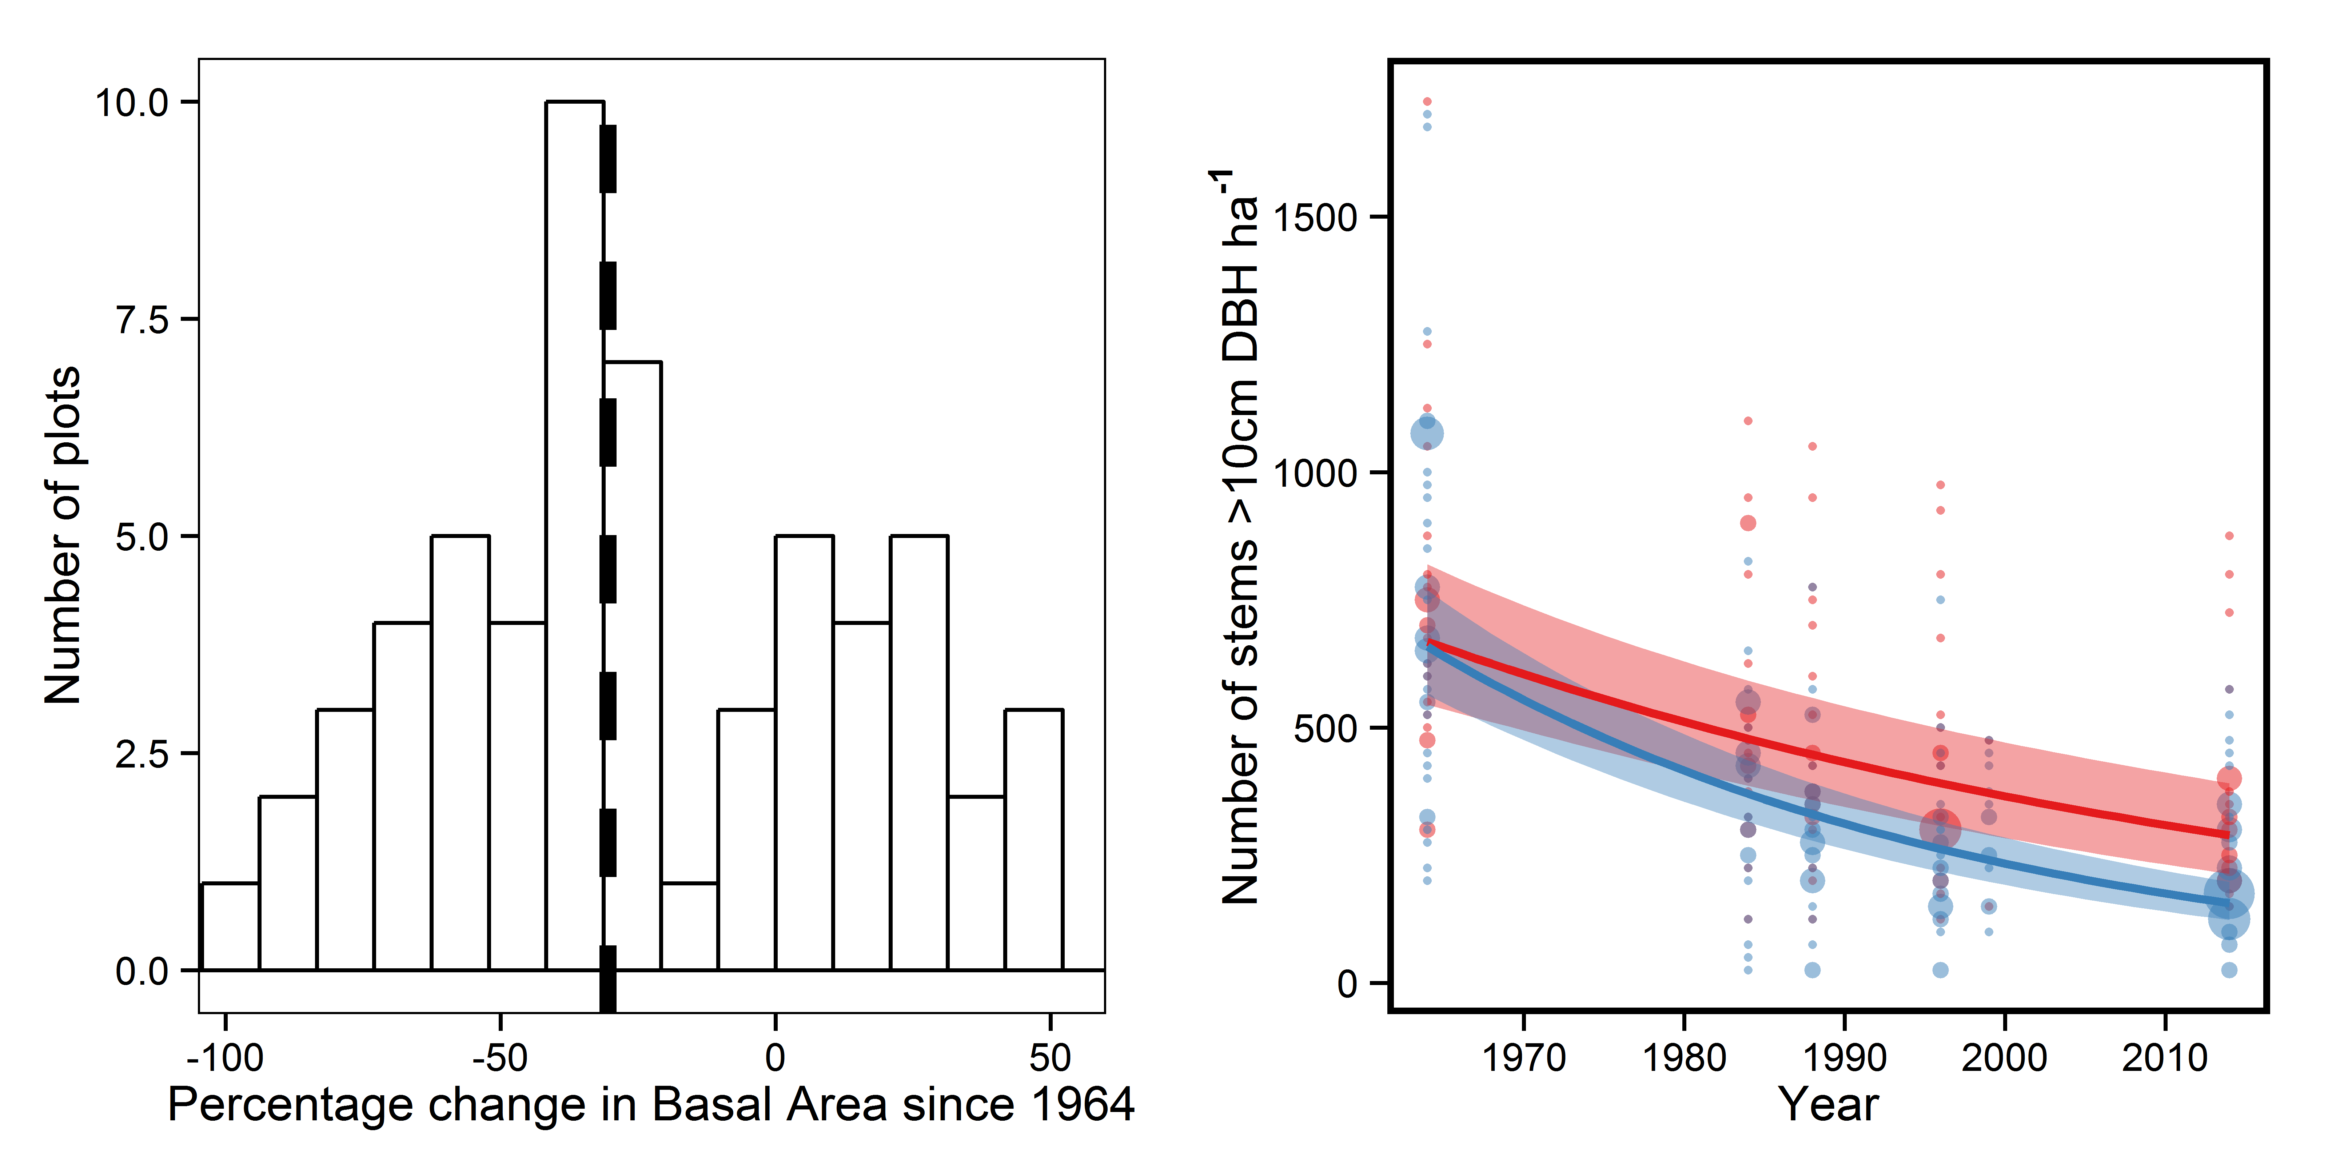

Figure 1 – Changes in (a) basal area and (b) stem density for subplots over the period 1964-2014. In (a) the dashed line represents the median change in basal area. In (b) points represent individual subplots, with collapsed subplots coloured red and stable subplots blue, lines represent predictions from the most parsimonious model and bands the 95% confidence intervals of these predictions (marginal R2=0.37). Data from both the enclosed and unenclosed transects are used.

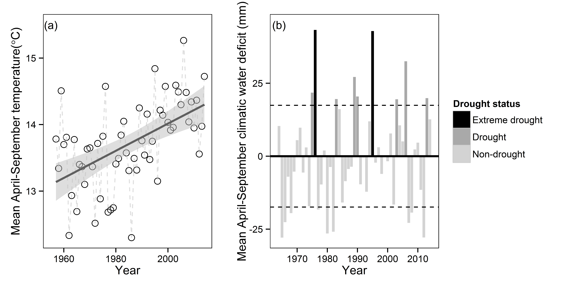

Figure 2 – Climate records from 1964-2014 showed that (a) mean temperature during April-September increased from 1960’s to present day at a rate of 0.02 ± 0.004°C year-1 (model R2=0.28); and (b) there were numerous drought years (water deficit > 1 SD from mean deficit) post 1976. In (a) points represent means of each year, with the solid line representing predictions from a regression; the band around this represents the 95% confidence intervals of the prediction. In (b) dotted lines represent the mean April-September water deficit ± 1SD. Refer to methods section for definitions of drought status. Data taken from the Hurn weather station, 24km from the study site (data available from www.metoffice.gov.uk/public/weather/climate-historic/ - accessed 16/04/2015).

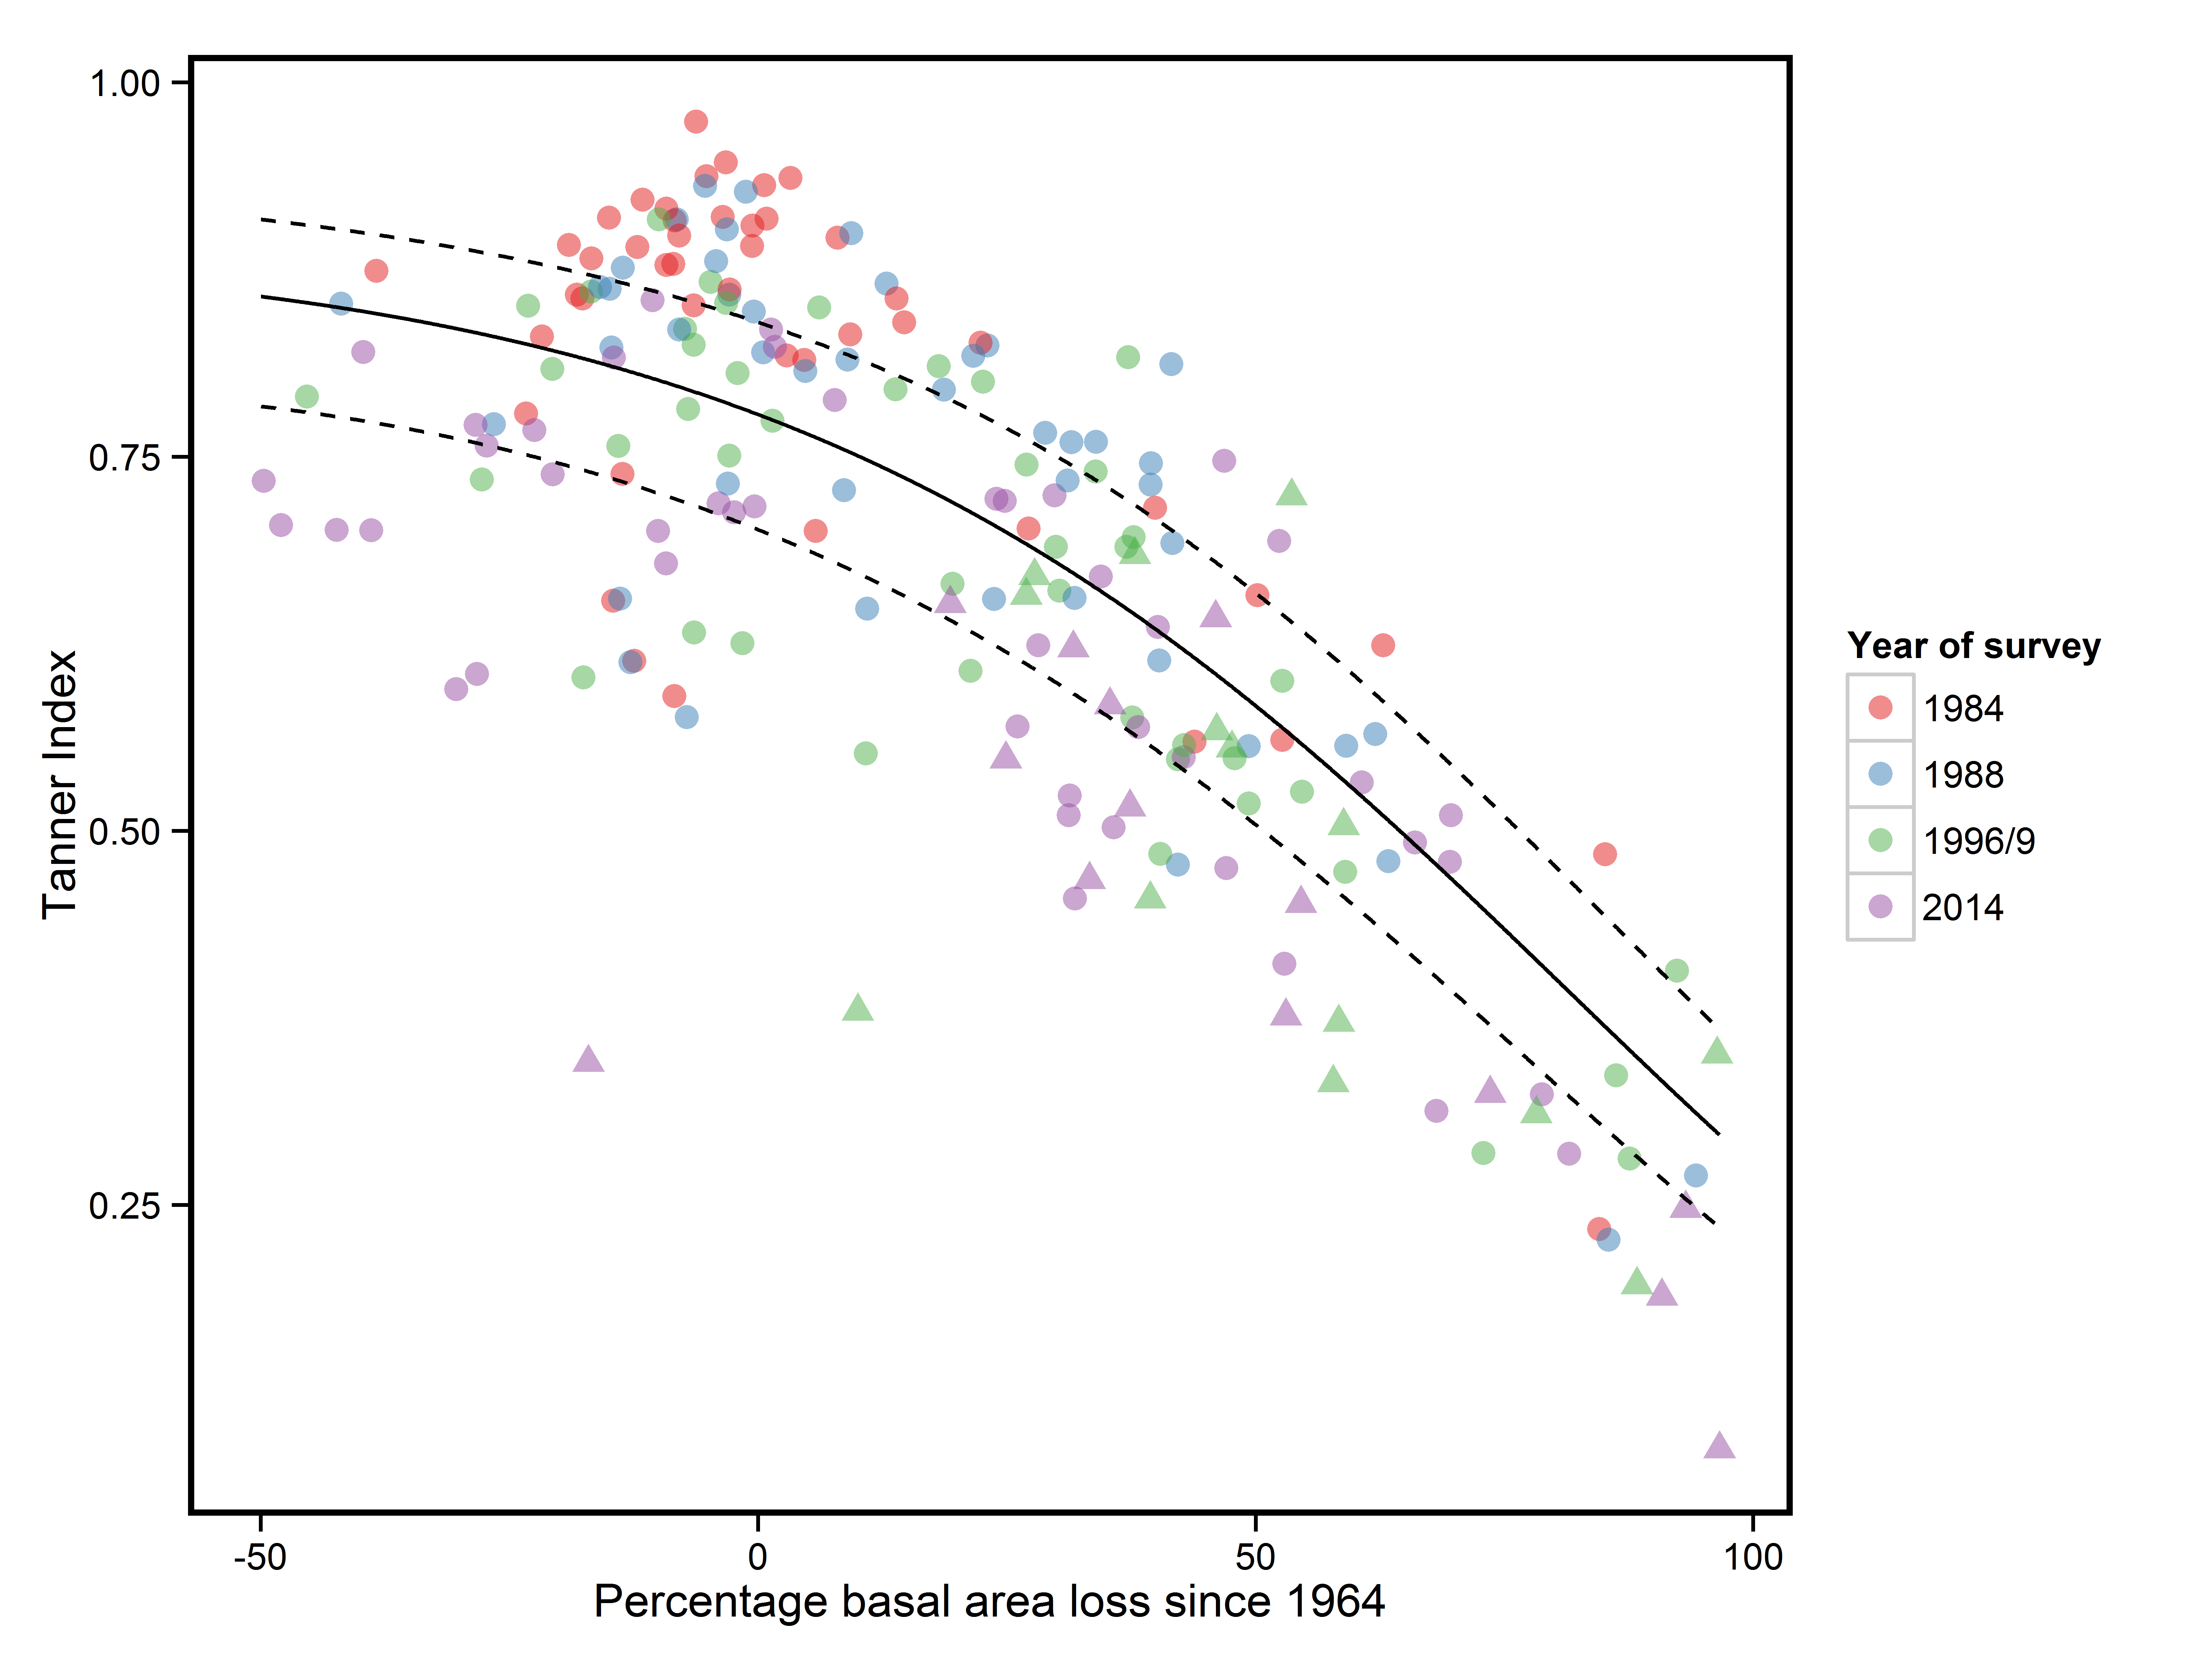

Figure 3 – Relationship between percentage loss in plot basal area and species composition changes as measured using the Tanner Index (n=210). Where Tanner Index values are closer to 1 species composition is more similar to the same plot in 1964. Points represent individual plots surveyed in 1984 (red), 1988 (blue), 1996/9 (green), or 2014 (purple). Circles represent plots on the enclosed transect and triangles circles those on the unenclosed transect. The line represents the most parsimonious model fit (R2=0.47), with dashed lines representing the 95% confidence intervals around the coefficient. For more details of model see Tables S13 and S14.

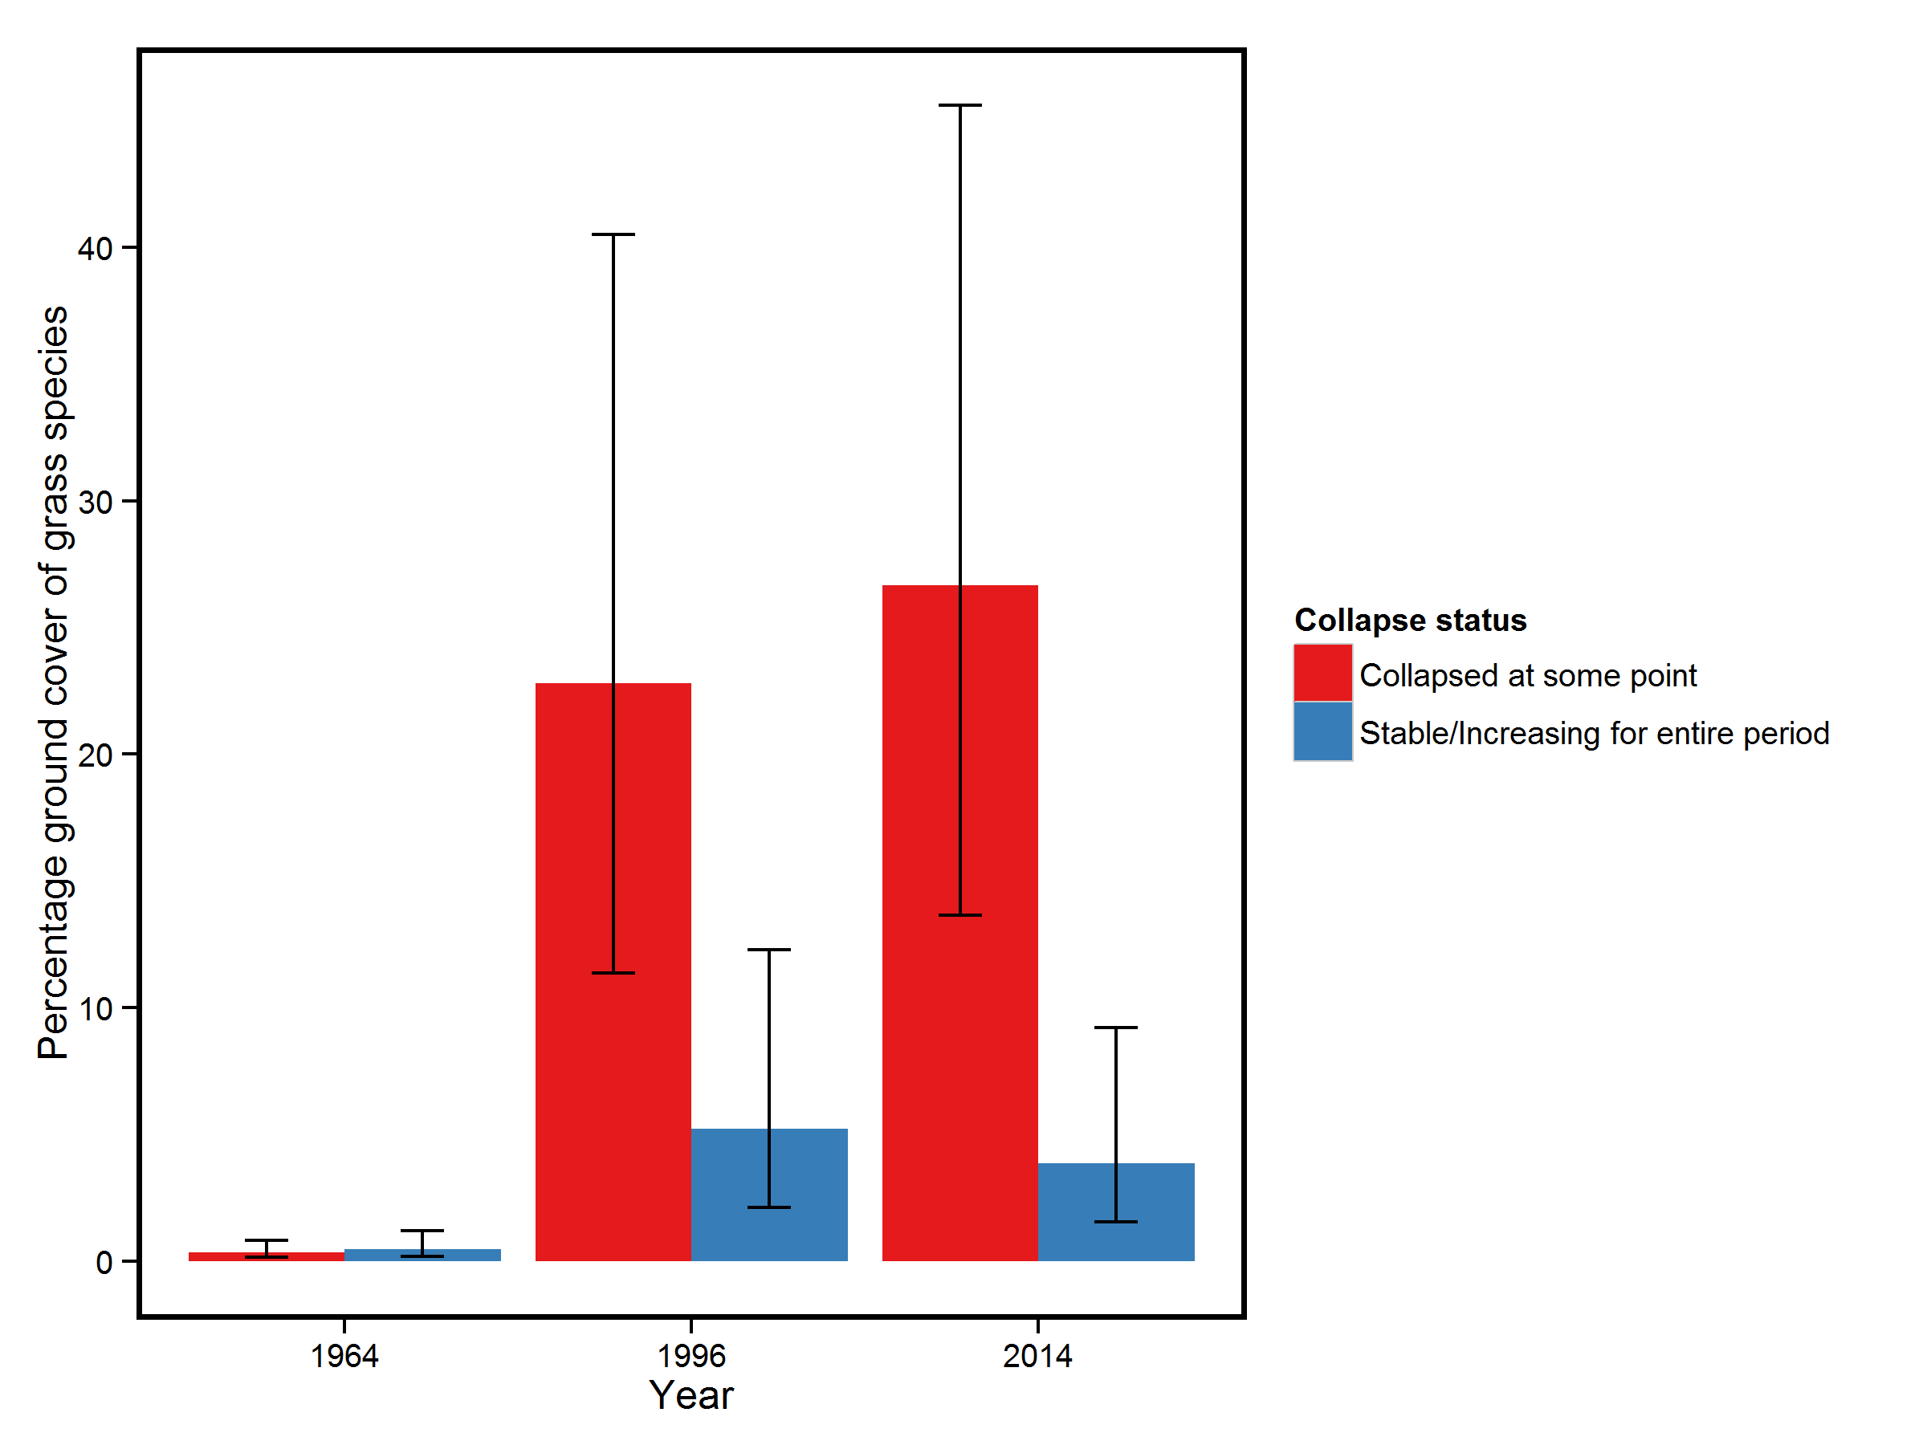

Figure 4 – Changes in mean subplot percentage grass cover for the enclosed area of Denny wood, for subplots that collapsed at some point from 1964-2014 (red bars) and those that were stable during this period (blue bars). Error bars represent 95% confidence intervals of the most parsimonious model explaining changes in grass cover (marginal R2=0.44). There was no difference amongst subplot grass cover in 1964 but by 1996 collapsed subplots had significantly greater grass cover than stable subplots (P=0.009) and this difference increased by 2014 (P<0.001). Only subplots from the enclosed transect are included in this figure as data on ground cover was missing for the unenclosed transect for 1964.

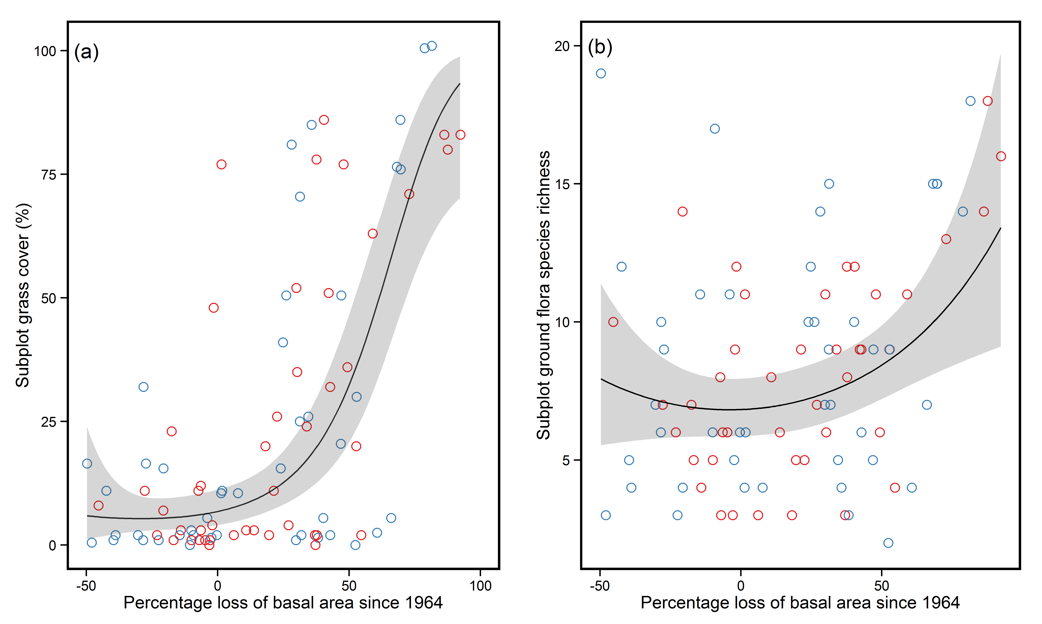

Figure 5 – Relationship between percentage loss in subplot basal area and (a) percentage grass cover and (b) ground flora species richness. Circles represent individual subplots on the enclosed transect surveyed in 1996 (red) or 2014 (blue). The line represents prediction using model averaged coefficients and grey shading the 95% confidence intervals of the coefficients (marginal R2=0.39 and 0.15 for grass cover and ground flora richness respectively). Only data from enclosed transect subplots are included in this figure.